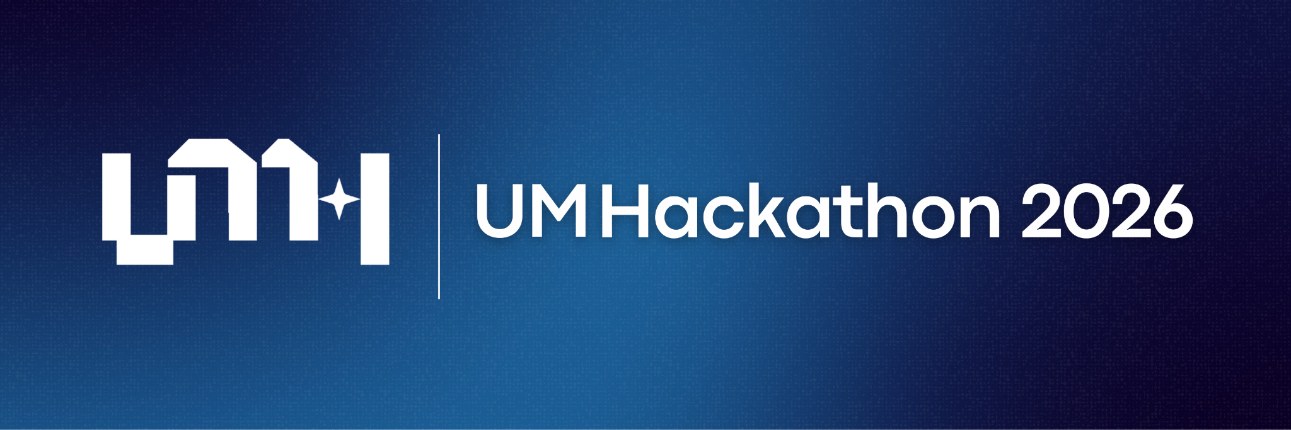

Participant Handbook
UMHackathon 2026
umhackathon@um.edu.my
_______________________________________________

Deliverables Guidelines
  - Deliverables Submission Rules
    - Deliverable submission is strictly restricted to the official UMHackathon 2026 website. Participating teams are explicitly prohibited from submitting artefacts, codebases, or documentation through any secondary platforms, email, or alternative channels unless formally directed otherwise by the organising committee.
    - Each participating team has only one submission attempt. Upon the execution of the final submission, the action becomes strictly irreversible. No subsequent modifications, addenda, or rectifications to the submitted deliverables will be permitted under any circumstances. Teams must exercise rigorous quality assurance before finalising their submission.

  - Deliverables Submission Procedure
    - To initiate the submission process, participants must authenticate their digital identity by logging into the designated portal on the UMHackathon 2026 website. Participants will receive the password through their registered email.
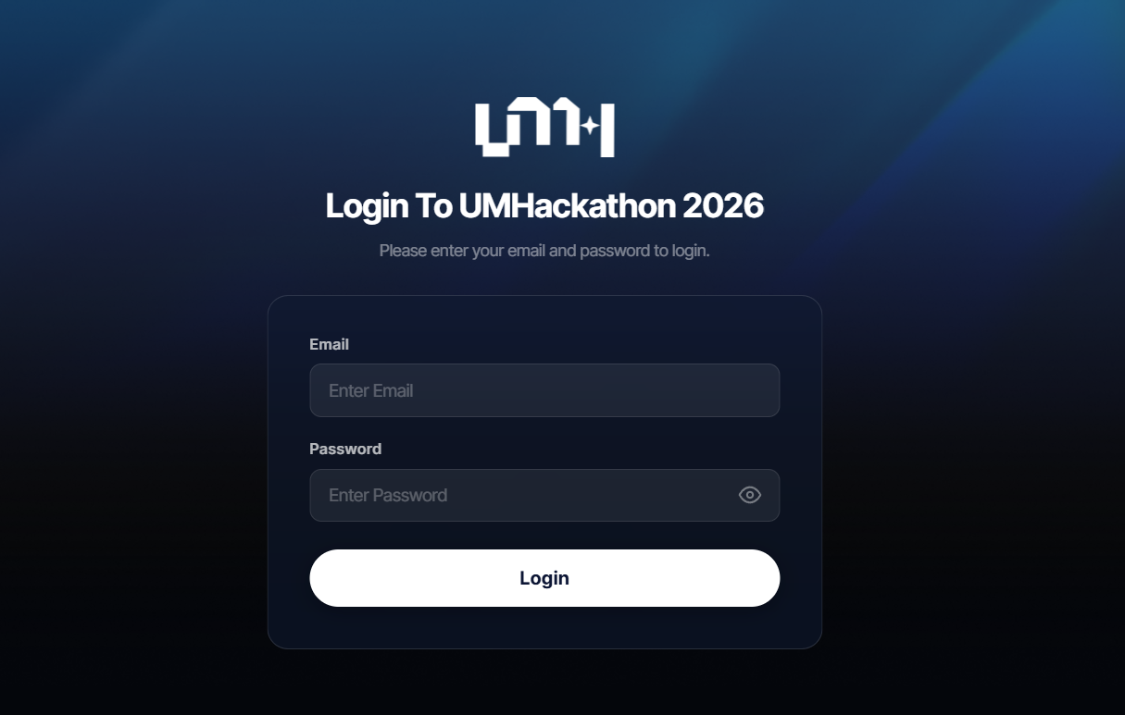
    - Teams are mandated to navigate to the ‘Submit Deliverables’ interface and accurately complete all necessary information fields to reflect their functional prototype. These required parameters include:
- Group name
- Domain Number
- Prototype Link (e.g., a secure URL linking to the designated GitHub repository).
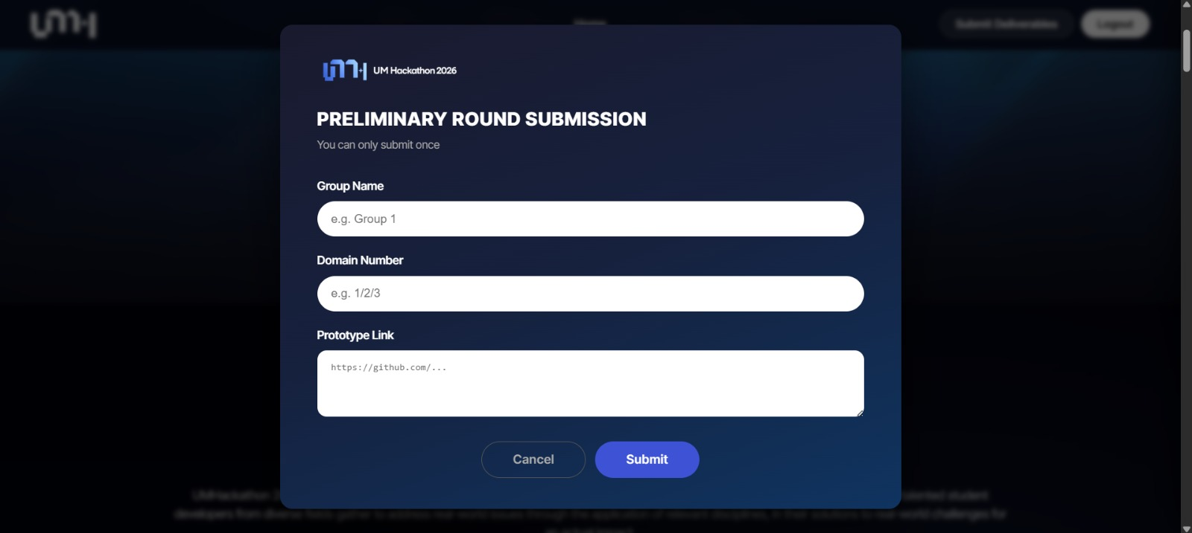

    - Before clicking the ‘Submit’ button, the team representative must meticulously verify all input data and repository links. In accordance with Section 1.1.2, executing this final command locks the submission permanently.
    - For more explanation of the submission process, participants may refer to the video here.

Mentorship Guidelines
  - Mentorship Booking Guidelines
    - Each team is only allowed to book one mentorship session for the preliminary round. Participants will be given a Calendly link to book their mentorship session with their mentors.
    - In the event of any team being unable to book a mentorship session slot, participants are instructed to promptly notify an official committee member. The organising committee will subsequently intervene to facilitate a necessary alternative arrangement to ensure equitable access to mentorship sessions.
    - On the Calendly link that will be provided, each team may book a session that is available, depending on the mentor. Please ensure that the team is able to attend the mentorship session that is chosen. Participants may refer to the image attached.

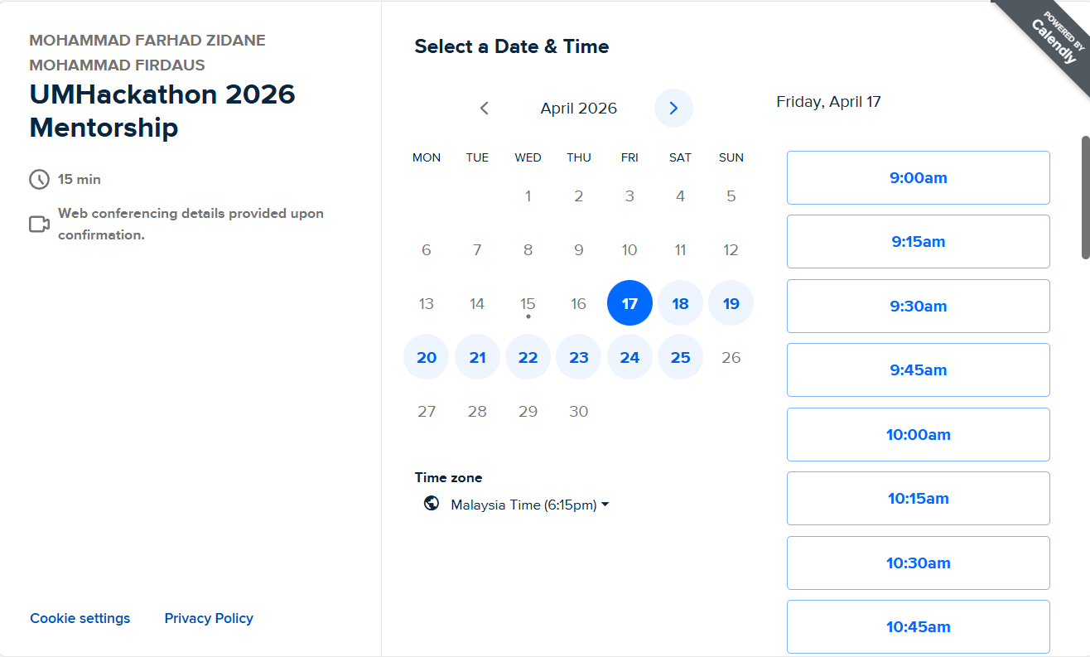

    - Once the team has chosen a mentorship session slot, the team leader will be required to fill in their name and email address. Participants may refer to the image attached.
    - Once a mentorship session has been scheduled, the team leader will receive the corresponding meeting link that will be shared through the UMHackathon 2026 Official Discord server. The team leader is required to share the link with all team members.g
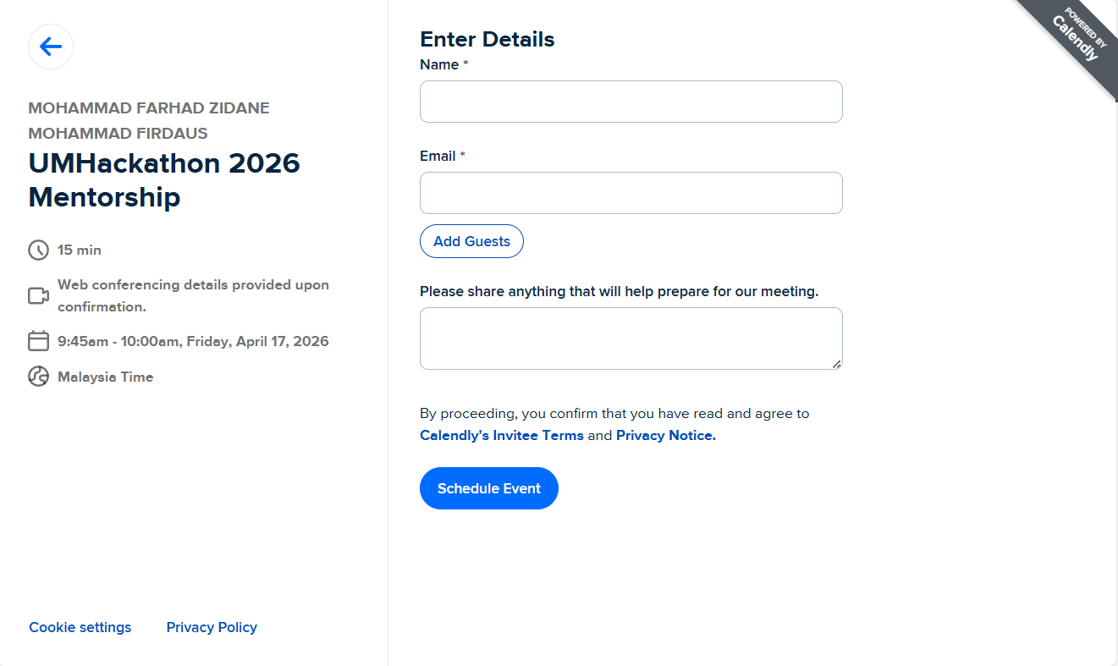
    - For a more detailed explanation, participants may refer to this video.

